**Source Code:**

print("Enter three sides: ")

a=int(input())

b=int(input())

c=int(input())

if(a+b<=c) or (a+c<=b) or (c+b<=a):

print("Triangle can be formed ")

else:

print("Triangle cannot be formed ")

**Output:**

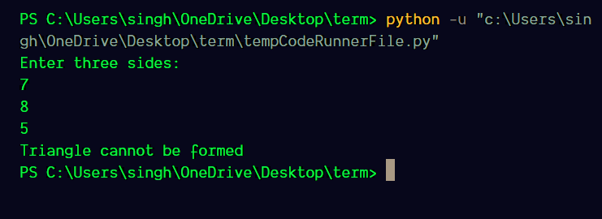

**Source code:**

char=input("Enter a character: ")[0]

if(char.islower()):

print(char+" is lower case")

elif(char.isupper()):

print(char+" is upper case")

elif(char.isdigit()):

print(char+" is a digit")

else:

print(char+" is a special")

**Output:**

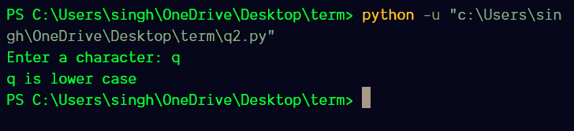

**Source code:**

num=int(input("Enter a number: "))

count=0

while(num>0):

count+=1

num=num//10

print(count,"digit number")

**Output:**

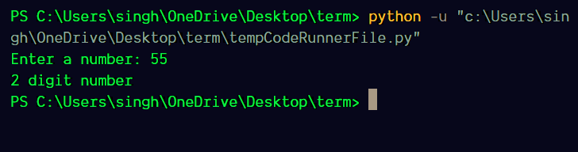

**Source Code:**

list1=[]

square=[]

limit=int(input("Enter the amount of numbers:- "))

i=0

while(i<limit):

list1.append(int(input("Enter number :- ")))

square.append(list1[i]**2)

i+=1

print("Entered list:- ",list1)

print("Squared list:- ",square)

**Output:**

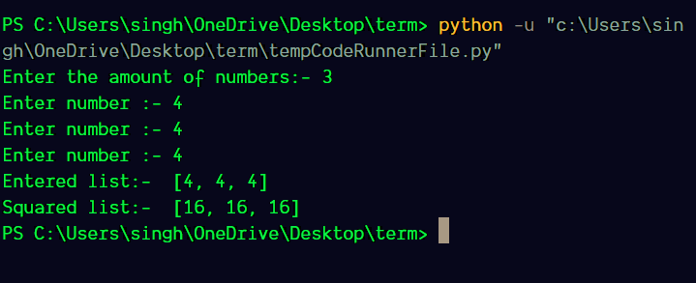

**Source Code:**

list1=[]

positive=[]

negative=[]

limit=int(input("Enter the amount of numbers:- "))

i=0

while(i<limit):

list1.append(int(input("Enter number:- ")))

if(list1[i]>0):

positive.append(list1[i])

else:

negative.append(list1[i])

i+=1

print("Original list:- ",list1)

print("Positive list:- ",positive)

print("Negative list:- ",negative)

**Output:**

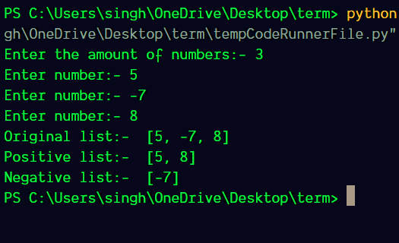

**Source Code:**

start=int(input("Enter starting range:- "))+1

end=int(input("Enter ending range:- "))

while(start<end):

i=2

count=0

while(i<start):

if(start%i==0):

count+=1

i+=1

if(count==0):print(start)

start+=1

**Output:**

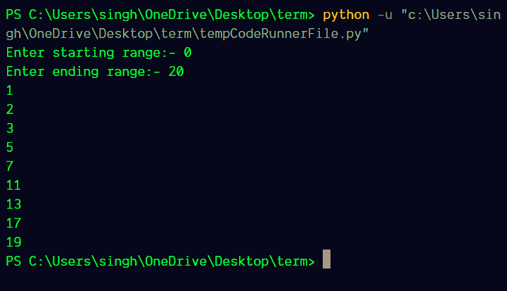

**Source Code:**

i=0

j=1

while(i<9):

print(j*'*')

if(i>=4):j-=1

else:j+=1

i+=1

**Output:**

